A1_Problem4

Julie

Thu Feb 1 10:14:05 2018

library("gurobi")

## Loading required package: slam

library("Matrix")  
library("igraph")

##   
## Attaching package: 'igraph'

## The following objects are masked from 'package:stats':  
##   
## decompose, spectrum

## The following object is masked from 'package:base':  
##   
## union

n <- 7  
C.ij = matrix(c(10000, 82, 34, 64, 141, 201, 62, 82, 10000, 94, 124, 79, 142, 123, 34, 94, 10000, 57, 154, 214, 52, 64, 124, 57, 10000, 184, 244, 22, 141, 79, 154, 184, 10000, 81, 179, 201, 142, 214, 244, 81, 10000, 239, 62, 123, 52, 22, 179, 239, 10000), nrow = n, ncol=n, byrow = TRUE)  
cvec = as.vector(t(C.ij))  
  
bvec = c(rep(1, n), rep(1, n))  
dir = c(rep("=", n), rep("=", n))  
  
  
Amat = Matrix(0, nrow = (n + n), ncol = (n * n))  
for (j in 1:n) {  
 Amat[j, seq(j, by = n, length.out = n)] = 1  
 Amat[j, ((j - 1) * n + j)] = 0  
}  
for (i in 1:n) {  
 Amat[n + i, ((i - 1) * n + 1):(i * n)] = 1  
 Amat[n + i, ((i - 1) * n + i)] = 0  
}  
  
myLP = list()  
myLP$obj = cvec  
myLP$A = Amat  
myLP$sense = dir  
myLP$rhs = bvec  
myLP$vtypes = "B"  
# myLP$vtypes = "C"  
# myLP$ub = 1  
  
check = F  
  
  
mysol = gurobi(myLP)

## Optimize a model with 14 rows, 49 columns and 84 nonzeros  
## Variable types: 0 continuous, 49 integer (49 binary)  
## Coefficient statistics:  
## Matrix range [1e+00, 1e+00]  
## Objective range [2e+01, 1e+04]  
## Bounds range [1e+00, 1e+00]  
## RHS range [1e+00, 1e+00]  
## Found heuristic solution: objective 936.0000000  
## Presolve removed 0 rows and 7 columns  
## Presolve time: 0.00s  
## Presolved: 14 rows, 42 columns, 84 nonzeros  
## Variable types: 0 continuous, 42 integer (42 binary)  
##   
## Root relaxation: objective 4.140000e+02, 11 iterations, 0.00 seconds  
##   
## Nodes | Current Node | Objective Bounds | Work  
## Expl Unexpl | Obj Depth IntInf | Incumbent BestBd Gap | It/Node Time  
##   
## * 0 0 0 414.0000000 414.00000 0.00% - 0s  
##   
## Explored 0 nodes (11 simplex iterations) in 0.01 seconds  
## Thread count was 4 (of 4 available processors)  
##   
## Solution count 2: 414 936   
##   
## Optimal solution found (tolerance 1.00e-04)  
## Best objective 4.140000000000e+02, best bound 4.140000000000e+02, gap 0.0000%

x.ij = matrix(mysol$x, nrow = n, ncol = n, byrow = T)  
   
myG = graph_from_adjacency_matrix(x.ij, weighted = T)  
plot(myG)

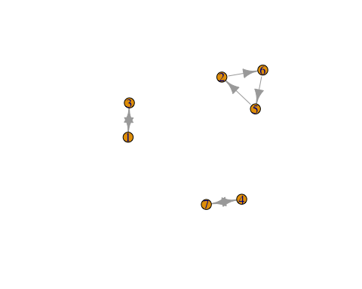

decomposed.graph = clusters(myG)  
if (decomposed.graph$no > 1) {  
 for (i in 1:decomposed.graph$no) {  
 cities = which(decomposed.graph$membership == i)  
 links = t(combn(cities, 2))  
 d.ij = matrix(0, n, n)  
 for (m in 1:nrow(links)) {  
 d.ij[links[m, 1], links[m, 2]] = 1  
 }  
 d.ij = d.ij + t(d.ij)  
 myLP$A = rBind(myLP$A, as.vector(d.ij))  
 myLP$rhs = c(myLP$rhs, (length(cities) - 1))  
 myLP$sense = c(myLP$sense, "<=")  
 }  
}  
if (decomposed.graph$no == 1) {  
 check = T  
}  
#  
  
  
  
while (!check) {  
 params = list(OutputFlag = 0)  
 mysol = gurobi(myLP, params)  
 x.ij = matrix(mysol$x, nrow = n, ncol = n, byrow = T)  
   
 myG = graph_from_adjacency_matrix(x.ij, weighted = T)  
   
 decomposed.graph = clusters(myG)  
 if (decomposed.graph$no > 1) {  
 for (i in 1:decomposed.graph$no) {  
 cities = which(decomposed.graph$membership == i)  
 links = t(combn(cities, 2))  
 d.ij = matrix(0, n, n)  
 for (m in 1:nrow(links)) {  
 d.ij[links[m, 1], links[m, 2]] = 1  
 }  
 d.ij = d.ij + t(d.ij)  
 myLP$A = rBind(myLP$A, as.vector(d.ij))  
 myLP$rhs = c(myLP$rhs, (length(cities) - 1))  
 myLP$sense = c(myLP$sense, "<=")  
 }  
 }  
 if (decomposed.graph$no == 1) {  
 check = T  
 }  
}  
plot(myG)

